##### AUTO COLORIZATION OF IMAGES

**Rashid Mazhar**

**Guided by: Maddhuja Sen**

School of Computer Science ,KIIT,

[21052780@kiit.ac.in](mailto:21052780@kiit.ac.in)

Supervisior Email Id: 2028021@kiit.ac.in

***Abstract*-**One of the recommended techniques to safeguard a culture is through the documentation, the dissemination, and enhancement of cultural heritage. Tangible or intangible cultural heritage such as historical images reveal an undeniable expression, richness, and diversity of cultures  Besides the ancient techniques which were used to protect the historical images, a new technological paradigm such as 3D modeling or auto-colorization provides a fascinating visual appearance.This document describes an AI system for the automatic colorization of black and white images.The system uses novel deep learning model to accurately colorize input images while maintaining their natural visual characteristics. In addition,the system is designed to be fast and efficient, allowing for the rapid colorization of images,the system is adaptable and customizable,allowing users to fine-tune the parameters to achieve the desired output. Our technique works by training a model on a corpus of images, then using the model to colorize grayscale images of a similar type.

***Index Terms***- AI(artificial intelligence),automatic,deep learning,adaptable,customizable,parameters,

Model,grayscale.

1. **Introduction**

Colorization, which is the process of adding colors to grayscale images or monochrome videos, has been an active research field. Conventionally, optimization methods that optimize every pixel based on user inputs or reference images are used as the mainstream for colorization. However, with the rapid advance of deep learning in recent years methods that use a CNN to automatically perform colorization have dominated the current trend. In such methods, deep networks are trained with a large number of images so they can output a colorized image given a grayscale image. This research builds a colorization deep neural network that can colorize cultural, heritage, and historical images of ancient Nepal that are black and white in just a few seconds without user-intervention CNN combines both local and global image features. Local features are based on small areas of pixels while a global feature resembles the whole content in the image so that the model can understand what is in the picture.

For color conversion, International Commission on Illumination (CIE) *L*\**a*\**b*\* color space is employed where model predicts chroma (*a*\*, *b*\*) values given Luminance value. More specifically, Red, Green, and Blue (RGB) image is first converted to CIE *L*\**a*\**b*\* color space. This is because the luminance (*L*) channel acts as grayscale input to our model. The two channel outputs *a*\* and *b*\* represent colors for the grayscale images. A basic concatenation between input and output is required to obtain three-channel image. Finally, *L*\**a*\**b*\* to RGB conversion is made to get an image in RGB color space.

In order to train, test, and validate the colorization model I created a dataset of 5000 images consisting of different themes of images.

First of all, a random collection of both RGB and black and white images was made for train and test datasets, respectively. Images having unusual aspect ratios—low-resolution and high degradation—were removed in the first stage. Then, cropping and resizing are applied to fix the resolution to 256 × 256. Then, 256 × 256 × 3 images were converted to CIE *L*\**a*\**b*\* color model because this model converts RGB images into the three corresponding color layers; two chroma components (*a*\* and *b*\*) and a luminance (*L* that contains image features) component. An image in *L*\**a*\**b*\* color space has one layer for luminance, and packed three RGB layers into two chroma layers. This illustrates that the original luminance value present in the image can be used for final color prediction. Here, the model just needs to predict two chroma channels from a given grayscale value. After that, pixel values for *L* (Lightness/Luminance), *a*\* (Green-red), and *b*\* (Blue-yellow) components are scaled and centered such that obtained values are between −1 and 1.

1. **Study of similar projects or technology\ literature review**

Existing work with image colorization typically uses one of two approaches. The first approach attempts to interpolate colors based off color scribbles supplied by an artist. Levin et al develop an optimization-based approach which colors pixels based on neighbors with similar intensities. et al further build on this work by not only grouping neighboring pixels with similar intensities, but also remote pixels with similar texture

The second approach to colorization has the user supply a reference image. The algorithm then attempts to transfer color information from the reference onto the input grayscale image. These algorithms typically work by matching up pixels or image regions by luminance. Bugeau and Ta propose a patch-based image colorization method that takes square patches around each pixel.

For our algorithm, we expand on the second approach, training a model over a corpus of images rather than a single image. Our goal is that, once the model is trained, users will not need to provide any input at all to the algorithm.

1. **Basic concepts/ Technology used**

By far, the most popular way of representing images is ****RGB****. But there are also different approaches available, and one of them is the ****Lab color space**** (also knows as CIELAB). In short the lab color space expresses colors as three values: L is for lightness on a scale from 0 to 100, a: green-red color spectrum,b: blue-yellow color spectrum.

The immediate conclusion we can draw from the description above is that by using the *Lab* color space we solve two issues at once — we have the grayscale image being the input and the complexity of the color channels is reduced from three to two (in comparison to RGB).

Autoencoders are a type of Neural Networks’ architecture that is similar to techniques such as the Principal Component Analysis — they both try to reduce the dimensionality of the input data. However, as we will see, autoencoders can do much more. They are built from two components:

* encoder — transforms the input data into a lower-dimensional representation (also known as the latent vector/representation). To achieve this goal, the encoder must learn only the most important features of the data.
* decoder — recovers the input from the low-dimensional representation.

In this project, I trained the autoencoders to minimize the loss function, which is a metric of the difference between the input data and the decoded output. Often, the latent representation can be used as the extracted features, analogically to the principal components . In our case, however, we are interested in the decoded output.

1. **Implementation and results**

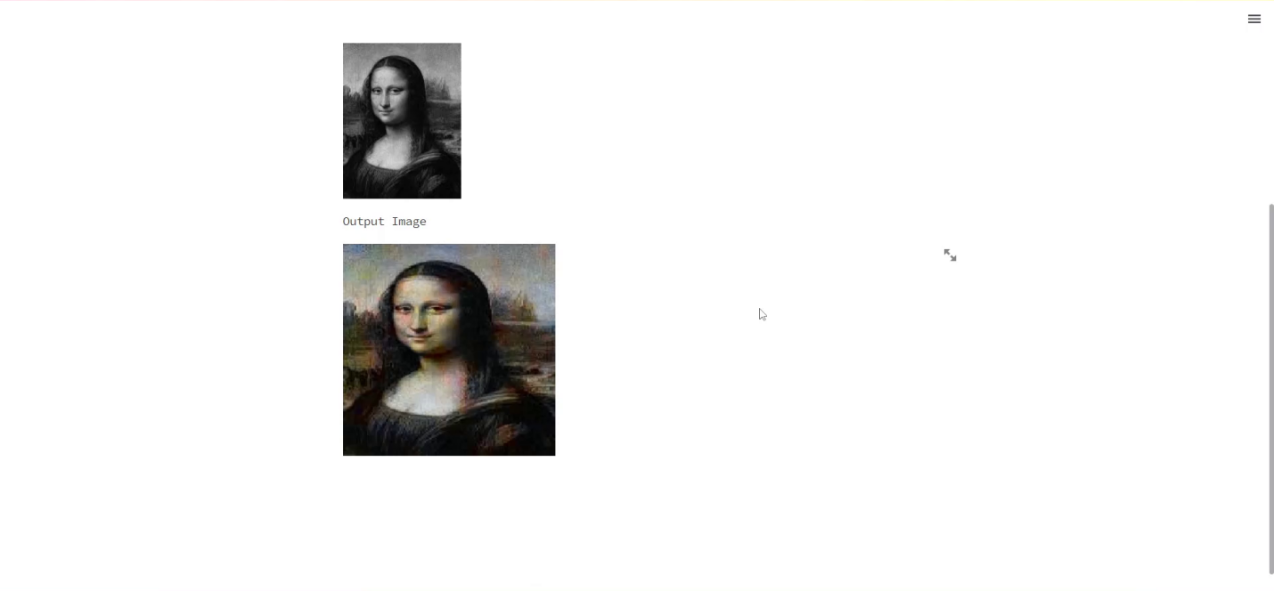

I observed that the model works well with low pixel images (around 250x250-450x450) because we are resizing the images for training to 255x255px so for images of high resolution the model is not able to perfectly add colors to the pixels, I will surely be looking forward to improve this in future.

1. **SOCIETAL IMPACT AND FUTURE SCOPE**

One of the recommended techniques to safeguard a culture is through the documentation, we can preserve the historic images and the images of our ancestors so that the history is remembered by many generations coming ahead. The image colorization systems find their applications in astronomical photography, CCTV footage, electron microscopy, etc.

1. **CONCLUSION**

Summing up, I really enjoyed working on this project and I learned quite a lot. By no means is the project complete and exhaustive. Image colorization is definitely not an easy task and I did not explore all the angles I had in mind, mostly due to time constraints.I do hope to come back to the project in the future and try some modifications to improve the outcome.

References

1. Radhakrishna Achanta, Appu Shaji, Kevin Smith, Aurelien Lucchi, Pascal Fua, and Sabine Susstrunk. Slic superpixels compared to state-of-the-art superpixel methods. Pattern Analysis and Machine Intelligence, IEEE Transactions on, 34(11):2274–2282, 2012.
2. Guillaume Charpiat, Matthias Hofmann, and Bernhard Scholkopf. Au- ¨ tomatic image colorization via multimodal predictions. In Computer Vision–ECCV 2008, pages 126–139. Springer, 2008.